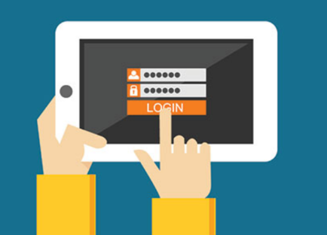

**Microsoft Student Log-in Directions**

Go to [myapps.microsoft.com](https://na01.safelinks.protection.outlook.com/?url=http%3A%2F%2Fwww.myapps.microsoft.com&data=02%7C01%7C%7C24239ac9196b4d11d69e08d61d868035%7Caa0b488ffc9e4185a5e3384220df23ca%7C0%7C0%7C636728860857051776&sdata=SR%2FKx0qrDMn6MM0tBo5gLaKJnjNzKqAaPcHNYA2AnM8%3D&reserved=0) (There is no “www” at the beginning.)

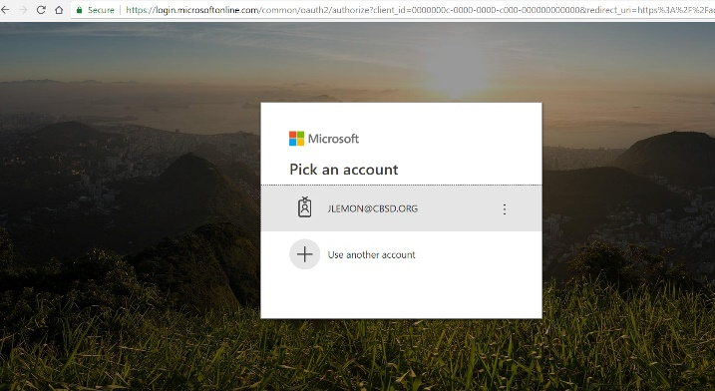

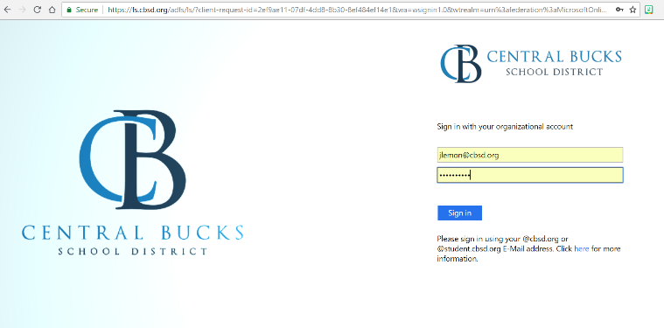Sign in with your CBSD email and password.

Your CBSD email.

Your Office 365 password.

You are now logged in and can access any of your CBSD apps.

**Tip!** Bookmark this page, so you don’t have to go though these steps each time.

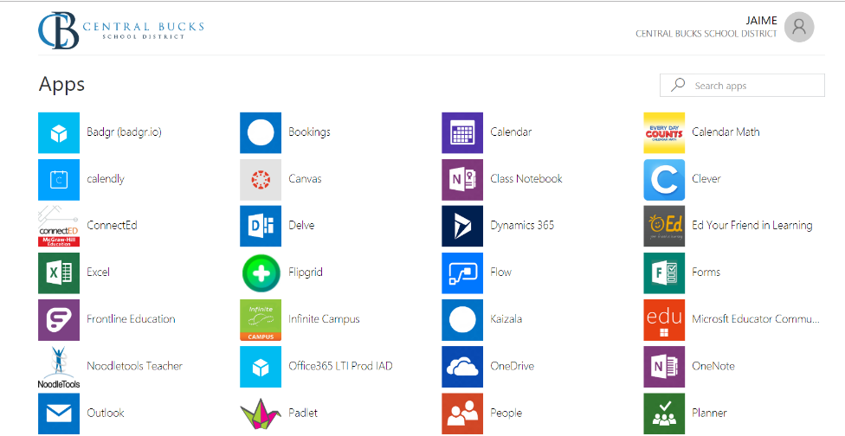

Click to log into Ed.